* SQLite Tutorial With Example In Android Studio

SQLite is a Structure query base database, open source, light weight, no network access and standalone database. It support embedded relational database features.

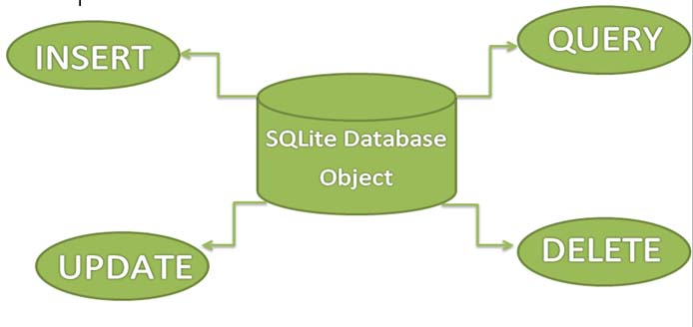

Whenever an application needs to store large amount of data then using sqlite is more preferable than other repository system like [SharedPreferences](https://abhiandroid.com/programming/shared-preference) or saving data in files.

Android has built in SQLite database implementation. It is available locally over the device(mobile & tablet) and contain data in text format. It carry light weight data and suitable with many languages. So, it doesn’t required any administration or setup procedure of the database.

**Important Note – The database created is saved in a directory: data/data/APP_Name/databases/DATABASE_NAME.**

**Creating And Updating Database In Android**

For creating, updating and other operations you need to create a subclass or *SQLiteOpenHelper*class. SQLiteOpenHelper is a helper class to manage database creation and version management. It provides two methods onCreate(SQLiteDatabase db), onUpgrade(SQLiteDatabase db, int oldVersion, int newVersion).

The SQLiteOpenHelper is responsible for opening database if exist, creating database if it does not exists and upgrading if required. The SQLiteOpenHelper only require the DATABASE_NAME to create database. After extending SQLiteOpenHelper you will need to implement its methods onCreate, onUpgrade and constructor.

**onCreate(SQLiteDatabase sqLiteDatabase)** method is called only once throughout the application lifecycle. It will be called whenever there is a first call to getReadableDatabase() or getWritableDatabase() function available in super SQLiteOpenHelper class. So SQLiteOpenHelper class call the onCreate() method after creating database and instantiate SQLiteDatabase object. Database name is passed in constructor call.

**onUpgrade(SQLiteDatabase db,int oldVersion, int newVersion)** is only called whenever there is a updation in existing version. So to update a version we have to increment the value of version variable passed in the superclass constructor.

In onUpgrade method we can write queries to perform whatever action is required. In most example you will see that existing table(s) are being dropped and again onCreate() method is being called to create tables again. But it’s not mandatory to do so and it all depends upon your requirements.

We have to change database version if we have added a new row in the database table. If we have requirement that we don’t want to lose existing data in the table then we can write alter table query in the onUpgrade(SQLiteDatabase db,int oldVersion, int newVersion) method.